#
# 20171130
#

# epel repository is required.
[root@m1-afs-prod ~]# yum install stress

# It’s only 4 core under load.
[root@m1-afs-prod ~]# stress -c 4
stress: info: [46142] dispatching hogs: 4 cpu, 0 io, 0 vm, 0 hdd

#
# In other opened terminal I run utility to see load in pseudographics.
[root@m1-afs-prod ~]# tload
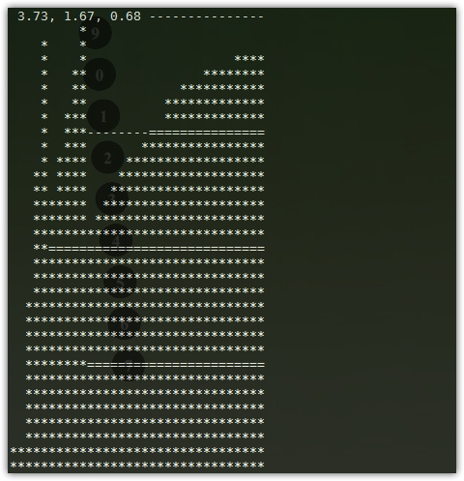
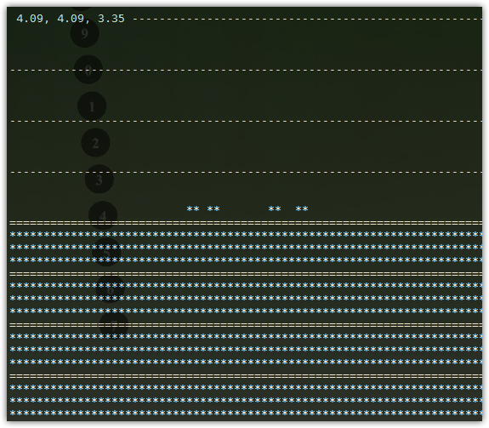

# In htop it looks like follow.
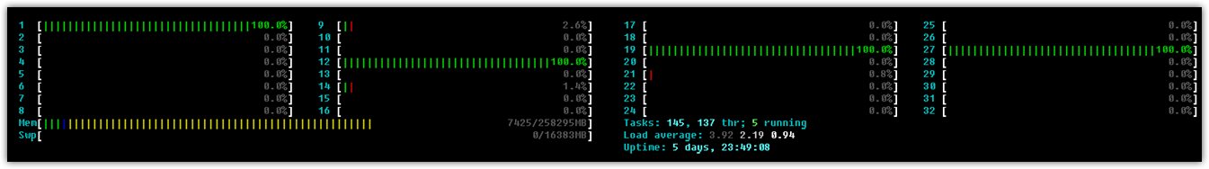

# The temperature of processors was increased only for one of them.
# This because I load only one processor.
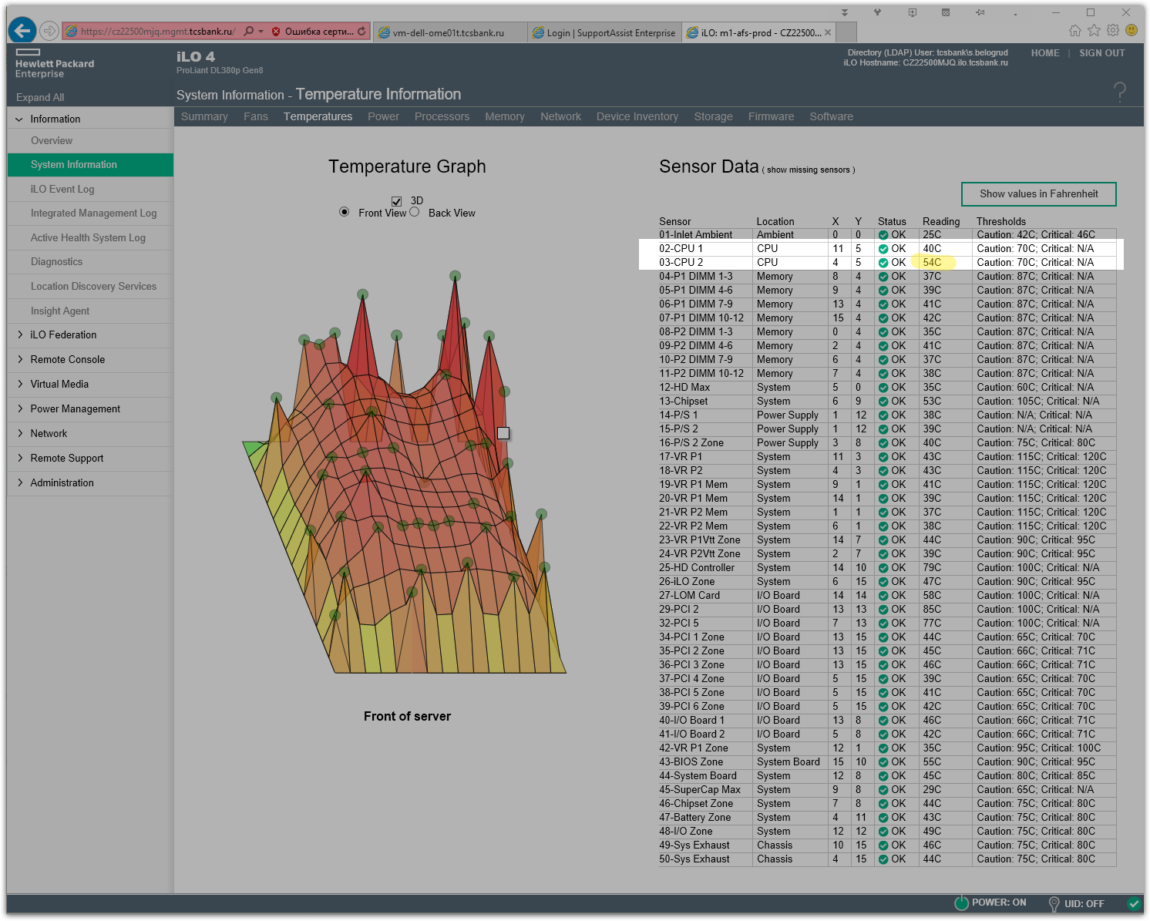

# But our 2 CPU has 32 cores.
[root@m1-afs-prod ~]# stress -c 32
stress: info: [48119] dispatching hogs: 32 cpu, 0 io, 0 vm, 0 hdd

# In other screen we see all cores of our two processors are loaded.
# Now htop show more better view.
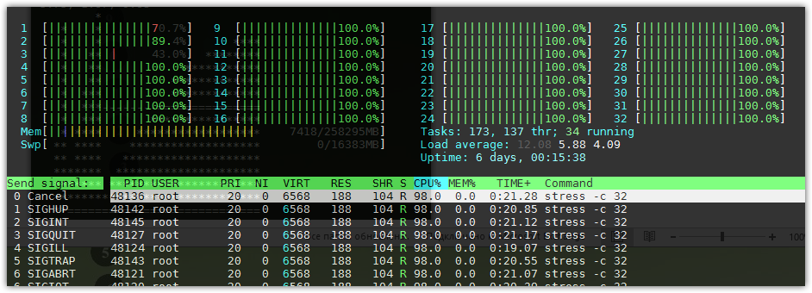

# In tload we can see follow.
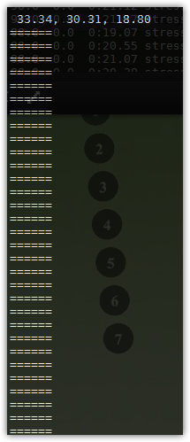

# We see equal temperature both of our processors.
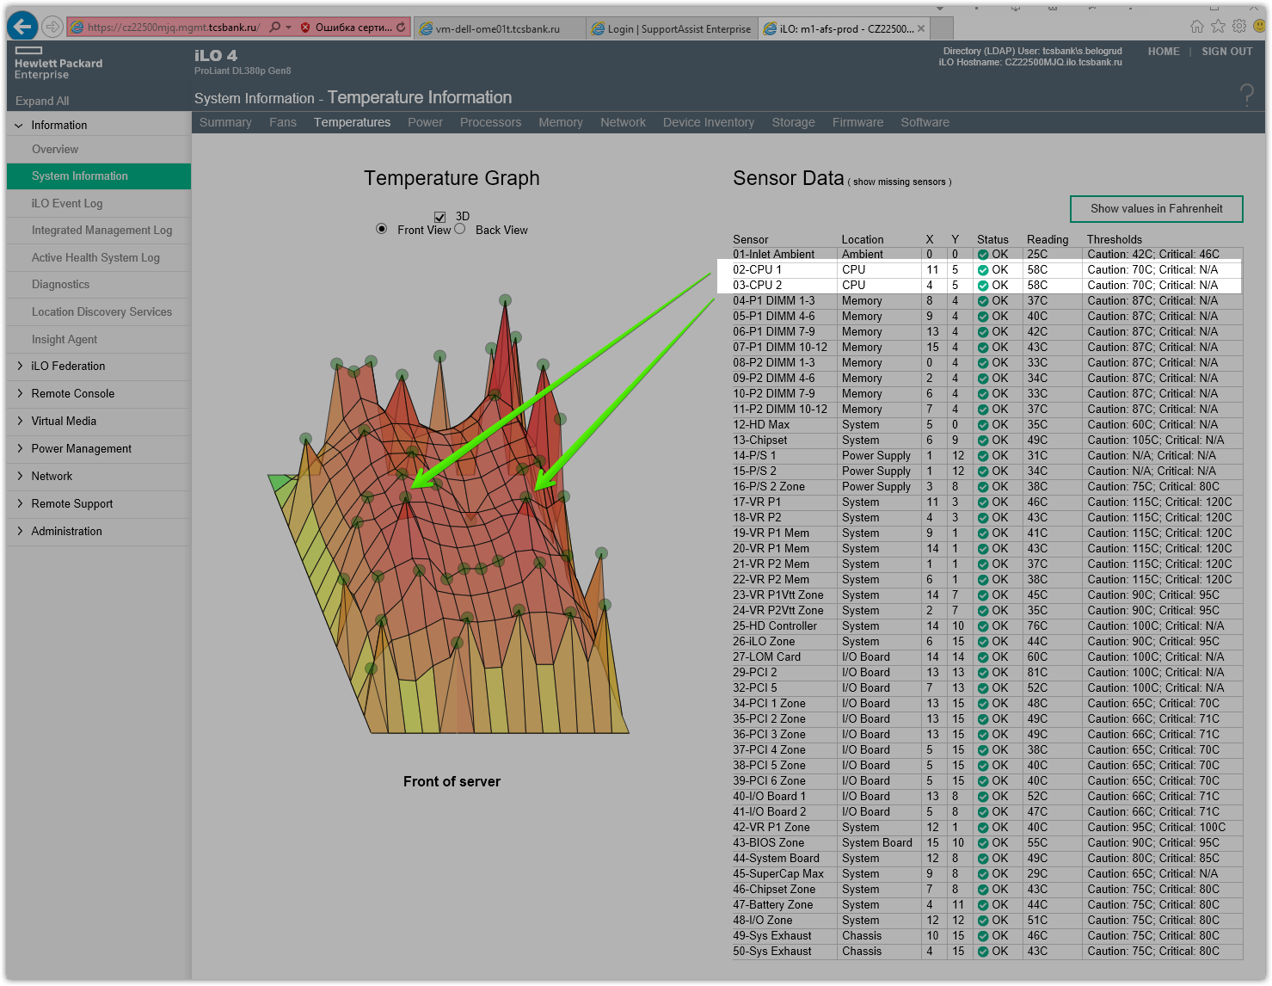

#
# At this server is present two physical processor chips.
#
[root@m1-afs-prod ~]# lscpu
Architecture: x86_64
CPU op-mode(s): 32-bit, 64-bit
Byte Order: Little Endian
CPU(s): 32
On-line CPU(s) list: 0-31
Thread(s) per core: 2
Core(s) per socket: 8
CPU socket(s): 2
NUMA node(s): 2
Vendor ID: GenuineIntel
CPU family: 6
Model: 45
Stepping: 7
CPU MHz: 1200.000
BogoMIPS: 5186.80
Virtualization: VT-x
L1d cache: 32K
L1i cache: 32K
L2 cache: 256K
L3 cache: 20480K
NUMA node0 CPU(s): 0-7,16-23
NUMA node1 CPU(s): 8-15,24-31
[root@m1-afs-prod ~]#

[root@m1-afs-prod ~]# dmidecode -t processor
# dmidecode 2.11
SMBIOS 2.8 present.
# SMBIOS implementations newer than version 2.7 are not
# fully supported by this version of dmidecode.

Handle 0x0400, DMI type 4, 42 bytes
Processor Information
Socket Designation: Proc 1
Type: Central Processor
Family: Xeon
Manufacturer: Intel
ID: D7 06 02 00 FF FB EB BF
Signature: Type 0, Family 6, Model 45, Stepping 7
Flags:
FPU (Floating-point unit on-chip)
VME (Virtual mode extension)
DE (Debugging extension)
PSE (Page size extension)
TSC (Time stamp counter)
MSR (Model specific registers)
PAE (Physical address extension)
MCE (Machine check exception)
CX8 (CMPXCHG8 instruction supported)
APIC (On-chip APIC hardware supported)
SEP (Fast system call)
MTRR (Memory type range registers)
PGE (Page global enable)
MCA (Machine check architecture)
CMOV (Conditional move instruction supported)
PAT (Page attribute table)
PSE-36 (36-bit page size extension)
CLFSH (CLFLUSH instruction supported)
DS (Debug store)
ACPI (ACPI supported)
MMX (MMX technology supported)
FXSR (FXSAVE and FXSTOR instructions supported)
SSE (Streaming SIMD extensions)
SSE2 (Streaming SIMD extensions 2)
SS (Self-snoop)
HTT (Multi-threading)
TM (Thermal monitor supported)
PBE (Pending break enabled)
Version: Intel(R) Xeon(R) CPU E5-2670 0 @ 2.60GHz
Voltage: 1.4 V
External Clock: 100 MHz
Max Speed: 4800 MHz
Current Speed: 2600 MHz
Status: Populated, Enabled
Upgrade: Socket LGA2011
L1 Cache Handle: 0x0710
L2 Cache Handle: 0x0720
L3 Cache Handle: 0x0730
Serial Number: Not Specified
Asset Tag: Not Specified
Part Number: Not Specified
Core Count: 8
Core Enabled: 8
Thread Count: 16
Characteristics:
64-bit capable

Handle 0x0401, DMI type 4, 42 bytes
Processor Information
Socket Designation: Proc 2
Type: Central Processor
Family: Xeon
Manufacturer: Intel
ID: D7 06 02 00 FF FB EB BF
Signature: Type 0, Family 6, Model 45, Stepping 7
Flags:
FPU (Floating-point unit on-chip)
VME (Virtual mode extension)
DE (Debugging extension)
PSE (Page size extension)
TSC (Time stamp counter)
MSR (Model specific registers)
PAE (Physical address extension)
MCE (Machine check exception)
CX8 (CMPXCHG8 instruction supported)
APIC (On-chip APIC hardware supported)
SEP (Fast system call)
MTRR (Memory type range registers)
PGE (Page global enable)
MCA (Machine check architecture)
CMOV (Conditional move instruction supported)
PAT (Page attribute table)
PSE-36 (36-bit page size extension)
CLFSH (CLFLUSH instruction supported)
DS (Debug store)
ACPI (ACPI supported)
MMX (MMX technology supported)
FXSR (FXSAVE and FXSTOR instructions supported)
SSE (Streaming SIMD extensions)
SSE2 (Streaming SIMD extensions 2)
SS (Self-snoop)
HTT (Multi-threading)
TM (Thermal monitor supported)
PBE (Pending break enabled)
Version: Intel(R) Xeon(R) CPU E5-2670 0 @ 2.60GHz
Voltage: 1.4 V
External Clock: 100 MHz
Max Speed: 4800 MHz
Current Speed: 2600 MHz
Status: Populated, Idle
Upgrade: Socket LGA2011
L1 Cache Handle: 0x0716
L2 Cache Handle: 0x0726
L3 Cache Handle: 0x0736
Serial Number: Not Specified
Asset Tag: Not Specified
Part Number: Not Specified
Core Count: 8
Core Enabled: 8
Thread Count: 16
Characteristics:
64-bit capable

[root@m1-afs-prod ~]#

https://www.cyberciti.biz/faq/stress-test-linux-unix-server-with-stress-ng/

How To Stress Test CPU and Memory (VM) On a Linux and Unix With Stress-ng
Posted onJanuary 29, 2015in CategoriesFreeBSD, Hardware, Linux, OpenBSD, UNIXlast updated January 30, 2015

Iwant test my Linux, OpenBSD, FreeBSD and Unix-like server entirely for high load and monitoring the health under stress. How can I stress out my CPU, memory, I/O, and disk stress and more with stress test tool on a Linux or Unix-like systems?

A sysadmin can try out any one of the following tool to put given subsytems under a specified load. Instances in which this is useful include those in which a system administrator wishes to perform tuning activities, a kernel or libc programmer wishes to evaluate denial of service possibilities, test your systems entirely on high load and monitoring the health, etc. This is also useful for sysadmin, system builders, and overclockers who want to test their hardware under high load and monitor stability and thermal environment.
- stress : It is a simple workload generator for POSIX systems. It imposes a configurable amount of CPU, memory, I/O, and disk stress on the system. It is written in C, and is free software licensed under the GPLv2. It is not a benchmark, but is rather a tool designed
- stress-ng : It is an updated version of stress tool and it will stress test a server for the following features:
  - CPU compute
  - Cache thrashing
  - Drive stress
  - I/O syncs
  - VM stress
  - Socket stressing
  - Context switching
  - Process creation and termination
  - It includes over 60 different stress tests, over 50 CPU specific stress tests that exercise floating point, integer, bit manipulation and control flow, over 20 virtual memory stress tests.
Warning: Running the following tools with root privileges is recommended to avoid out of memory and other errors. Also, note that tools will stress out your server resources quickly so use the following command judiciously.

Tool#1: Getting started with stress tool
This program is supposed to be easy to use and recommended for new sysadmins. The tool is known to work on x86 Linux and FreeBSD/OpenBSD, powerpc AIX and Linux, SPARC Solaris, Compaq Alpha Tru64 UNIX, and many others.

Install stress package
You can install stress as part of the distribution.

INSTALL STRESS ON A CENTOS, RHEL, AND FEDORA LINUX
First, turn on EPEL repo and then type the following yum command to install the same:
sudo yum install stress
Sample outputs:
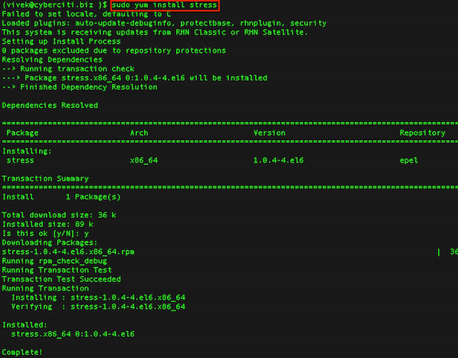Fig.01: Installing stress on a RHEL/CentOS/Fedora Linux

INSTALL STRESS ON A DEBIAN AND UBUNTU LINUX
Type the following apt-get command to install the same:
apt-get install stress
Sample outputs:
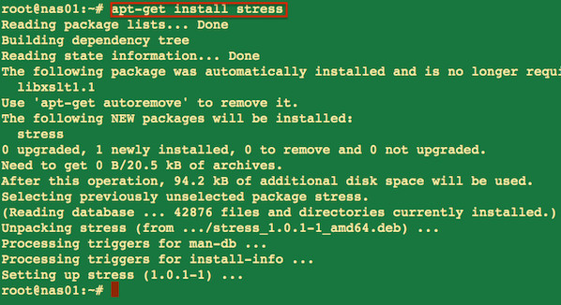Fig.02: Install stress tool on a Debian/Ubuntu Linux

INSTALL STRESS ON A FREEBSD
Type the following pkg command to install the stress tool using binary method:
pkg install stress
## OR ##
pkg install sysutils/stress
Sample outputs:
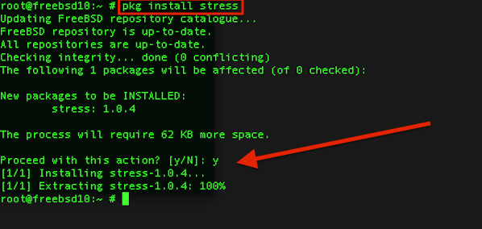Fig.03: FreeBSD installing stress tool

INSTALL STRESS ON A OPENBSD
Type the following pkg_add command to install the stress tool using binary method:
export PKG_PATH=http://ftp.usa.openbsd.org/pub/OpenBSD/`uname -r`/packages/`arch -s`
pkg_add stress

How do I use stress tool?
First, note down the current system load averages by typing the following command:
# uptime
Next, run any one of the following command to see load on screen:
# watch uptime
OR use tload command:
# tload
The syntax is as follows:
stress [OPTION]
## Stress using CPU-bound task
stress -c 4
## Stress using IO-bound task
stress -i 2
For example, a load average of four is imposed on the system by specifying two CPU-bound processes, one I/O-bound process, and one memory allocator process as follows:
# uptime
# stress -c 2 -i 1 -m 1 --vm-bytes 128M -t 10s
# uptime

Sample outputs:
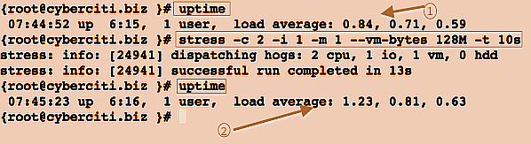Fig.04: A load average of four is imposed on the system
Where,
- -c 2 : Spawn two workers spinning on sqrt()
- -i 1 : Spawn one worker spinning on sync()
- -m 1 : Spawn one worker spinning on malloc()/free()
- --vm-bytes 128M : Malloc 128MB per vm worker (default is 256MB)
- -t 10s : Timeout after ten seconds
- -v : Be verbose

Tool #2: Getting started with stress-ng
The stress-ng tool will stress test a computer system in various selectable ways.

Install stress-ng on a Linux or Unix-like systems
Type the following command to download stress-ng tarball using the wget command:
$ cd /tmp
$ wget http://kernel.ubuntu.com/~cking/tarballs/stress-ng/stress-ng-0.03.11.tar.gz
Untar tar ball, enter:
$ tar zxvf stress-ng-0.03.11.tar.gz
Compile stress-ng, run:
$ cd stress-ng-0.03.11
$ make
Sample outputs:
cc -Wall -Wextra -DVERSION='"0.03.11"' -O2 -c -o stress-affinity.o stress-affinity.c
cc -Wall -Wextra -DVERSION='"0.03.11"' -O2 -c -o stress-aio.o stress-aio.c
cc -Wall -Wextra -DVERSION='"0.03.11"' -O2 -c -o stress-bigheap.o stress-bigheap.c
cc -Wall -Wextra -DVERSION='"0.03.11"' -O2 -c -o stress-brk.o stress-brk.c
cc -Wall -Wextra -DVERSION='"0.03.11"' -O2 -c -o stress-bsearch.o stress-bsearch.c
cc -Wall -Wextra -DVERSION='"0.03.11"' -O2 -c -o stress-cache.o stress-cache.c
cc -Wall -Wextra -DVERSION='"0.03.11"' -O2 -c -o stress-chmod.o stress-chmod.c
....
..
cc -Wall -Wextra -DVERSION='"0.03.11"' -O2 -c -o stress-ng.o stress-ng.c
cc -Wall -Wextra -DVERSION='"0.03.11"' -O2 stress-affinity.o stress-aio.o stress-bigheap.o stress-brk.o stress-bsearch.o stress-cache.o stress-chmod.o stress-clock.o stress-cpu.o stress-dentry.o stress-dir.o stress-dup.o stress-epoll.o stress-eventfd.o stress-fallocate.o stress-fault.o stress-fifo.o stress-flock.o stress-fork.o stress-fstat.o stress-futex.o stress-get.o stress-hdd.o stress-hsearch.o stress-inotify.o stress-iosync.o stress-kill.o stress-lease.o stress-lsearch.o stress-link.o stress-lockf.o stress-memcpy.o stress-mincore.o stress-mmap.o stress-msg.o stress-mq.o stress-nice.o stress-noop.o stress-null.o stress-open.o stress-pipe.o stress-poll.o stress-procfs.o stress-pthread.o stress-qsort.o stress-rdrand.o stress-rename.o stress-seek.o stress-sem.o stress-sendfile.o stress-sigfd.o stress-sigfpe.o stress-sigsegv.o stress-sigq.o stress-socket.o stress-stack.o stress-switch.o stress-sysinfo.o stress-timer.o stress-tsearch.o stress-urandom.o stress-utime.o stress-vm.o stress-wait.o stress-yield.o stress-zero.o coredump.o helper.o io-priority.o lock-mem.o log.o madvise.o mincore.o mounts.o mwc.o out-of-memory.o parse-opts.o proc-name.o sched.o time.o stress-ng.o -lm -lpthread -lrt -o stress-ng

How do I use the stress-ng tool?
The syntax is:
stress-ng [options]
stress-ng -c 2
stress-ng -c 4 -t 10 -v
stress-ng -c 4 --metrics-brief

EXAMPLES
To run for 60 seconds with 4 cpu stressors, 2 io stressors and 1 vm stressor using 1GB of virtual memory, enter:
stress-ng --cpu 4 --io 2 --vm 1 --vm-bytes 1G --timeout 60s --metrics-brief
Sample outputs:
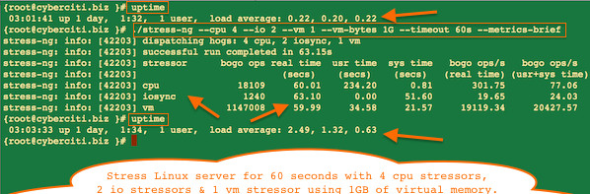Fig.05: stress-ng in action
In this example, run 16 cpu stressors and stops after 900000 bogo operations:
stress-ng --cpu 16 --cpu-ops 900000
To run 4 simultaneous instances of all the stressors sequentially one by one, each for 6 minutes and summaries with performance metrics at the end:
stress-ng --sequential 4 --timeout 6m --metrics
To run 2 FFT cpu stressors, stop after 5000 bogo operations and produce a summary just for the FFT results:
stress-ng --cpu 2 --cpu-method fft --cpu-ops 5000 --metricsâˆ’brief
To run cpu stressors on all online CPUs working through all the available CPU stressors for 2 hour:
stressâˆ’ng --cpu 0 --cpu-method all -t 2h
To run 2 instances of all the stressors for 10 minutes:
stress-ng --all 2 --timeout 10m
To run 128 stressors that are randomly chosen from all the available stressors:
stress-ng --random 128
To run 64 instances of all the different cpu stressors and verify that the computations are correct for 5 minutes with a bogo operations summary at the end:
stress-ng --cpu 64 --cpuâˆ’method all --verify -t 5m --metricsâˆ’brief
To run all the stressors one by one for 5 minutes, with the number of instances of each stressor matching the number of online CPUs:
stress-ng --sequential 0 -t 5m
To run all the stressors in the io class one by one for 1 minutes each, with 8 instances of each stressor running concurrently and show overall time utilisation statistics at the end of the run:
stress-ng --sequential 8 --class io -t 1m --times

References
- stress home page – Download source code and docs.
- stress-ng home page– Download source code and docs.

Posted by: Vivek Gite
The author is the creator of nixCraft and a seasoned sysadmin and a trainer for the Linux operating system/Unix shell scripting. He has worked with global clients and in various industries, including IT, education, defense and space research, and the nonprofit sector. Follow him on Twitter, Facebook, Google+.

